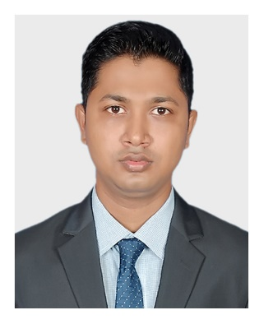Md. Mizanur Rahman

**Mailing Address**

**Address:** 257-258, Rose Elegance,

Ibrahimpur Primary School Road,

Ibrahimpur, Kafrul, Dhaka-1206

**Phone: 01680 225 343**

**Email:** [mohd.mizanur16@gmail.com](mailto:mohd.mizanur16@gmail.com)

**Career Objectives**

To work in an environment where there is an opportunity of self-assessment and self-improvement in both individual and group-based work that will ultimately lead to further development of the common people. And Looking for a challenging opportunity to sharpen my skills and knowledge in a fast-paced organization and to grow as a lead.

**Education**

* **Master of Social Science (M.S.S)**

Major Area : Economics

Result : On Progress

Institution : University Of Dhaka.

* **Bachelor of Social Science (B.S.S)**

Major Area : Economics

Passing Year : 2016

Result : 2.99 Out of 4.00

Institution : University Of Dhaka.

* **Higher Secondary Certificate (H.S.C)**

Institution : Adamjee Cantonment College

Group : Humanities

Board : Dhaka

Passing Year : 2011

GPA : 4.60

* **Secondary School Certificate (S.S.C)**

Institution : Uttar Kafrul High School

Group : Humanities

Board : Dhaka

Passing Year : 2009

GPA : 4.06

**Professional Training**

**IsDB IT Scholarship Project** (Graduate on February 2021)

* Enterprise System Analysis & Design – JEE

**Skill**

Languages: Java, SQL

Frameworks: Spring, Angular, Bootstrap, JSP

Mobile OS: Android

Libraries: JQuery, ReactJs

Database: MySQL, Oracle, SQLite

Others: GitHub, Html, CSS, JavaScript, NodeJs,

Concepts: UML, Digital Marketing

**Language Proficiency**

Bengali : Native speaker

English : Professional working efficiency

**Personal Information**

Father’s Name : Md. Babar Ali

Mother’s Name : Sultana Parvin

Date of Birth : 16th Nov, 1994

Gender : Male

Religion : Islam

Nationality : Bangladeshi

Marital Status : Single

NID : 5550086796

**References**

1. Md. Monir Hossain

Vice President

Al-Arafah Islami Bank Ltd, Gulshan Branch, South Breeze Square (1st & 2nd)

52, Gulshan Avenue, Gulshan Model Town, Dhaka-1212.

01712 819 097

1. Md. Masud Parveg

Principal Officer

Al-Arafah Islami Bank Ltd, Gulshan Branch, South Breeze Square (1st & 2nd) Gulshan Avenue, Gulshan Model Town, Dhaka-1212.

01816 660 358

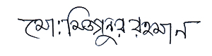

Signature Date: 14.02.2021